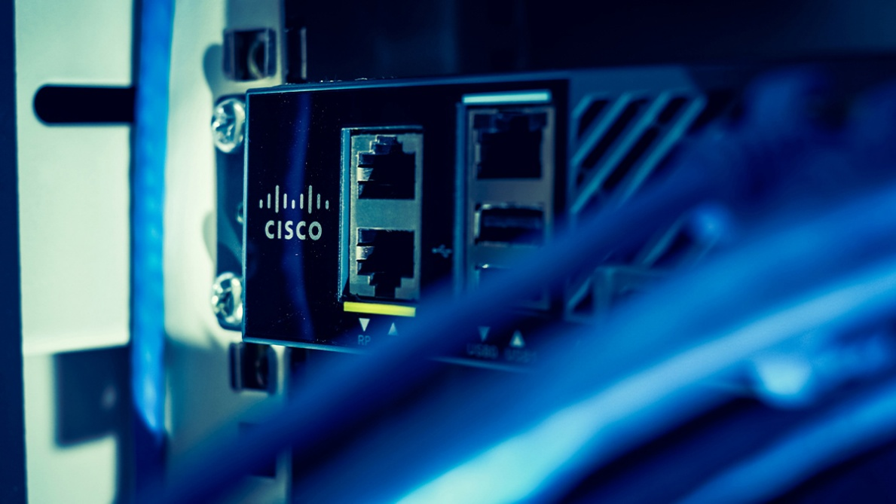
By Connor Ingle
Local AI Engine Lab

Cisco Certified Networking Program
Purpose:
The purpose of this lab was to create a local AI engine using a docker or python. It was also to learn how to use containers to be able to virtually control an operating system.
Background:
Docker has a set of products that use virtualization to use software in something called containers. It’s basically a tool that can be used to automatically deploy applications in containers so the apps can work faster and in their own environments. Containers are isolated from one another, but they can still communicate with each other through things called channels. And since they all use the same operating system piece, they use fewer resources than virtual machines, which can be really useful. Docker puts its dependencies in a virtual container that can run on any operating system. Since the Docker containers are lightweight, which means that they use lower memory and processor-speed, a single virtual machine can run multiple containers at the same time.
Llama is a series of large language models that have been released by Meta AI. They come in various sizes that range from 1 billion to 2 trillion parameters. For the first versions, Llama was only available to researchers. After the release of GPT-3, more research has been going into creating upscaling models. The success of ChatGPT brought a lot of attention towards large language models. Llama was trained using public information only, and in multiple sizes, with the intent of making it more accessible to different hardware. The Llama engineers focused their effort on increasing performance by using more references in the training sets, rather than the number of parameters per model.
AI basically uses “thinking” systems to do things with human intelligence. One problem of simulating intelligence is that reasoning and problem-solving algorithms are not good at solving large reasoning problems. They’re supposed to imitate humans when they solve problems or make logic-based decisions, but humans don’t use the same step-by-step process every time. And this is a problem for the simulation models, because they use fast judgements, that are based on steps and thinking that cannot match that of a human.

Lab Summary:
In this lab we used the software Docker to create a virtual container so that we could pull an AI model from Ollama and use it locally. We first downloaded Docker and installed it on the computer. We then created a container to use the AI model from Ollama in it. We installed Ollama and then pulled an AI model and got it working in the command prompt. We then pulled a UI interface so that we could use the AI model on the web, from multiple devices.
Lab Commands:
docker run –d –gpus=all -v ollama:/root/.ollama -p 11434:11434 –name ollama ollama/ollama
This command starts a new docker container and runs it with the name ollama with the port number 11434
docker exec -it ollama ollama run llama3:
This command tells the container where and what you want to run which in this case is the llama3 model
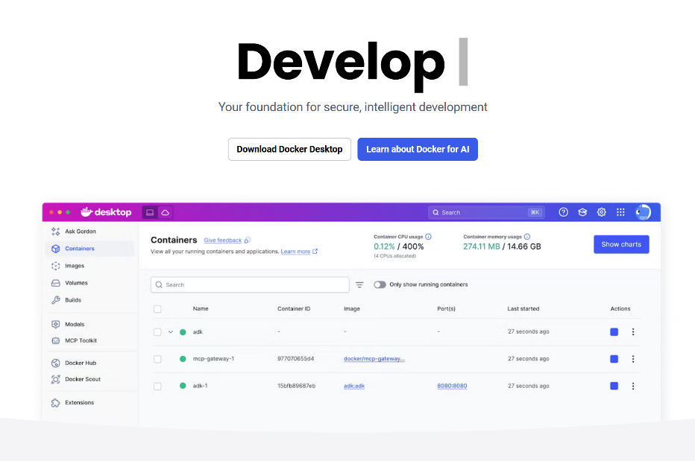
Configs:
Download Docker Software

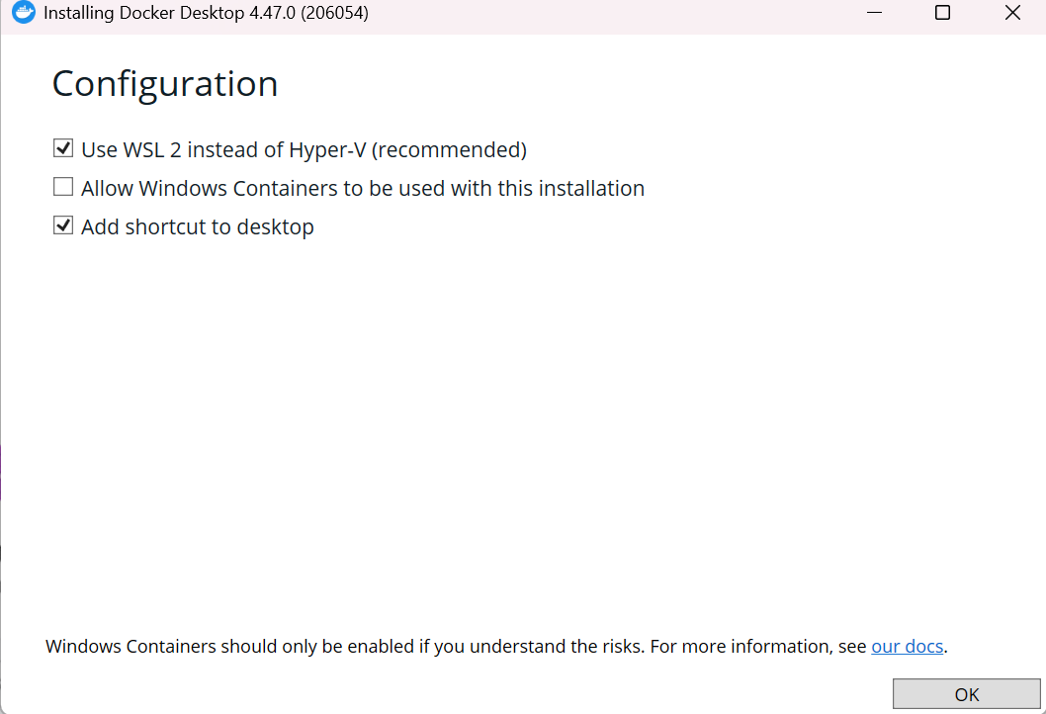
Hit OK to configurations

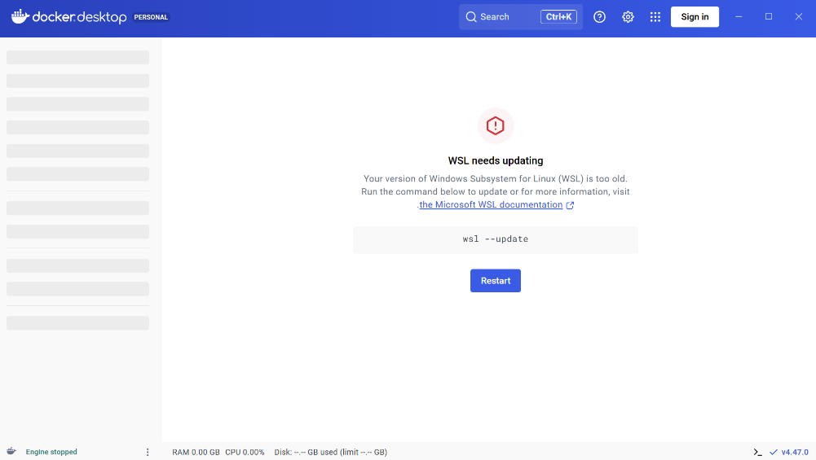
Click Restart

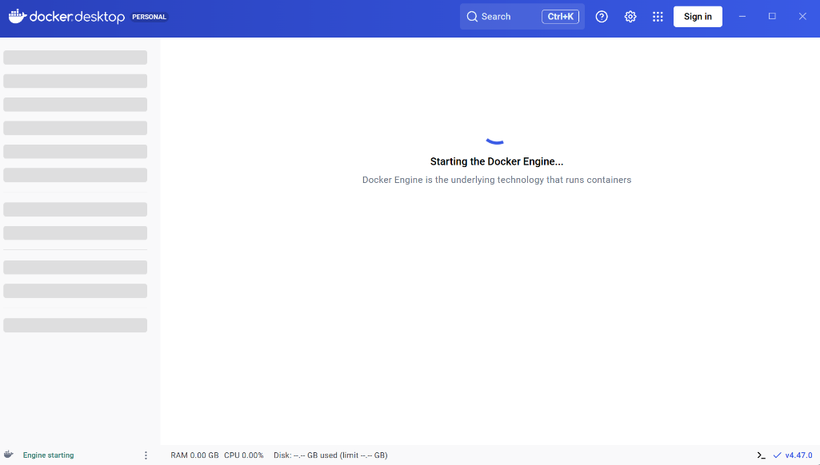
Wait for the Docker Engine to start

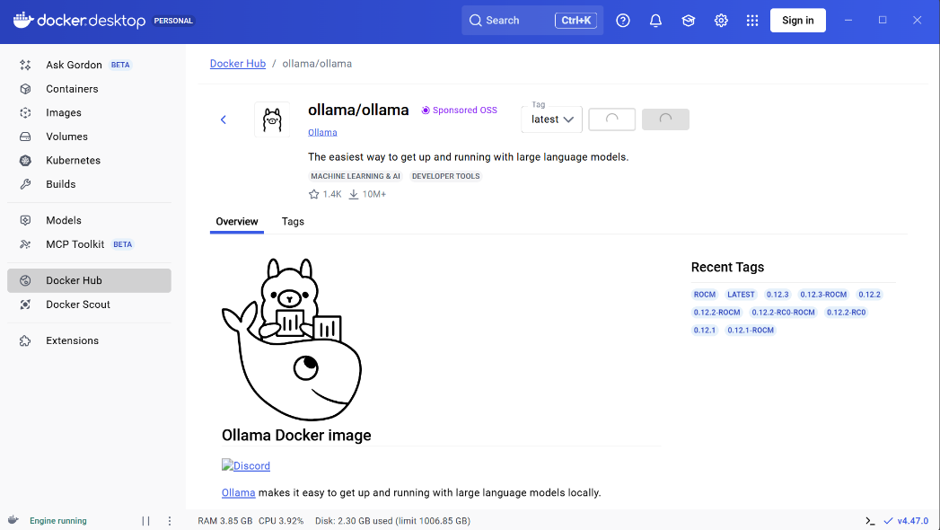
Search Ollama in the Docker Hub and click “Pull”

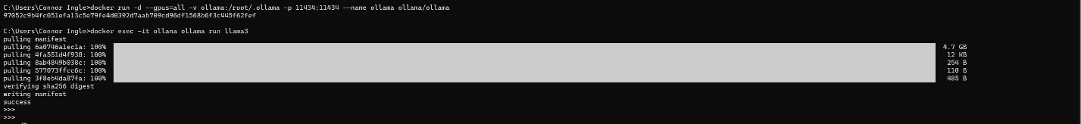
Use the “docker run –d –gpus=all -v ollama:/root/.ollama -p 11434:11434 –name ollama ollama/ollama” command, and then enter the command “docker exec -it ollama ollama run llama3” command to run the Ollama AI model

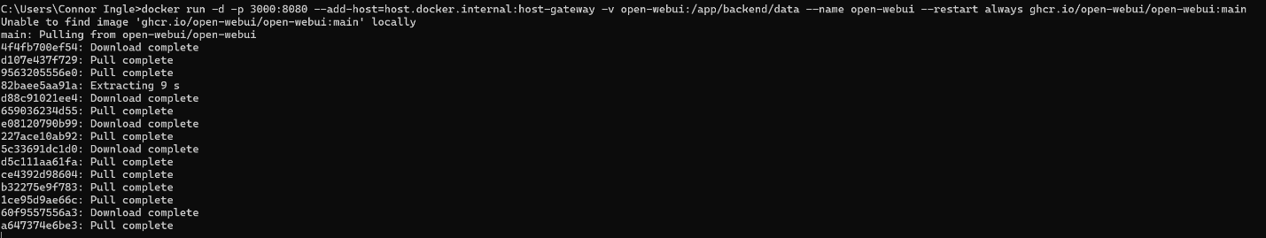
Find an open-source UI template and enter the run command for it and wait for the resources to pull

We can now see the UI template with our AI model in the containers list in the Docker software. Click the port number and a new tab will open in your browser
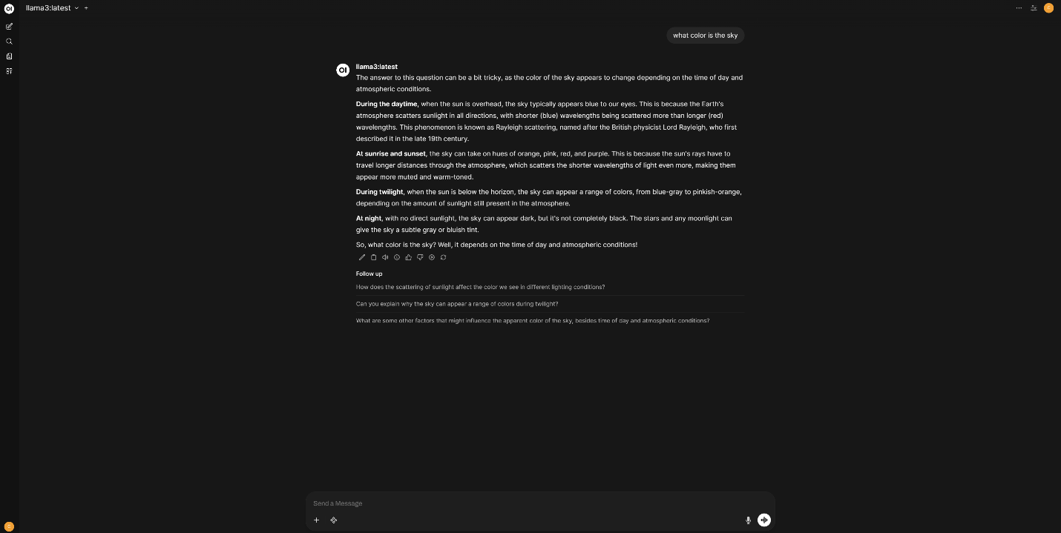
We can now use our AI model freely with our pulled UI template

Problems:
The problem we had was finding and using the right commands. When we first loaded up Docker and got into the command interface, we didn’t know what we were supposed to do next. We saw that we had to enter some sort of command to somehow connect the Docker to the Ollama AI engine, but we didn’t know which commands to use. We watched some different videos on Docker and Llama and got various results, still confused on what to enter. We finally went to the Ollama website and noticed that under the download button, there were commands to enter once we got Ollama ready on Docker. Those commands are the ones above in the Lab Commands section. We used those commands and we finally got through to the local AI and finally had a command prompt to ask the AI something, and this is when we moved on to working on getting the UI up and running.
Conclusion:
In conclusion, we learned how to use the Docker software to virtually pull an AI model from Ollama and use it locally on multiple devices. This is useful because that means that our AI model is private, and our data only stays on our machine. We can also use it without internet and Docker lets us package everything so that we can use our AI between different portable devices.

